
Final Project Report Template
1. Introduction
1.1. Project overviews
1.2. Objectives
2. Project Initialization and Planning Phase
2.1. Define Problem Statement
Project Initialization and Planning Phase

Date | 05-September-2026
Team ID | -
Project Name | AI Career Pulse: Decoding the Job Market
Maximum Marks | 3 Marks

Define Problem Statements (Customer Problem Statement Template):

Create a problem statement to understand your customer's point of view. The Customer Problem Statement template helps you focus on what matters to create experiences people will love. A well-articulated customer problem statement allows you and your team to find the ideal solution for your customers' challenges. Throughout the process, you’ll also be able to empathize with your customers, which helps you better understand how they perceive your product or service.

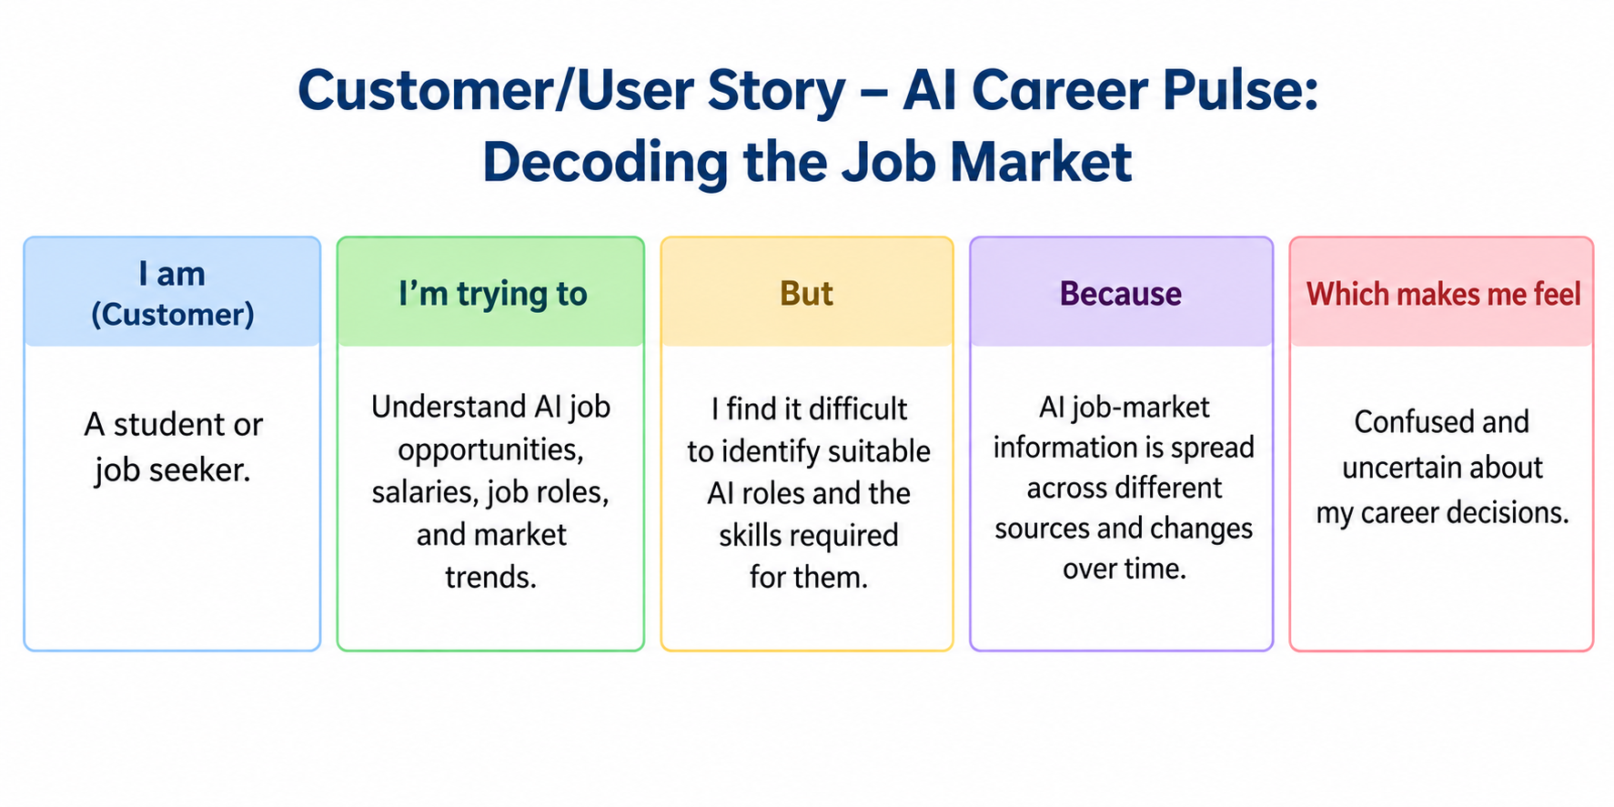

Problem  Statement (PS) | I am  (Customer) | I’m trying to | But | Because | Which makes me feel
PS-1 | A student or job seeker. | Find suitable career opportunities and understand current job market trends. | I find it difficult to identify in-demand skills and suitable job roles. | Job market information is scattered across different platforms and changes frequently. | Confused and uncertain about my career decisions.
PS-2 | A job seeker looking to improve my employability. | Identify the skills I need to learn to qualify for my desired job. | I do not know which skills are most relevant to current industry requirements. | I lack access to clear, personalized insights about job market demands and skill gaps. | Frustrated and worried about my future career opportunities.

2.2. Project Proposal (Proposed Solution)
Project Initialization and Planning Phase

Date | 05-September-2026
Team ID | -
Project Title | AI Career Pulse: Decoding the Job Market
Maximum Marks | 3 Marks

Project Proposal (Proposed Solution) template
This project proposal outlines a solution to address a specific problem. With a clear objective, defined scope, and a concise problem statement, the proposed solution details the approach, key features, and resource requirements, including hardware, software, and personnel.
Project Overview
Objective | To analyze AI job market data from 2025 to 2026 using Tableau Public Edition and extract useful insights about AI job roles, salaries, industries, company sizes, education requirements, and experience levels.
Scope | The project focuses on collecting and preparing AI job market data, analyzing employment trends, creating interactive visualizations and dashboards, and presenting insights through a Tableau story. It supports career exploration for freshers, mid-level professionals, and senior professionals.
Problem Statement
Description | Students and job seekers often face difficulties understanding AI job market trends, identifying suitable job roles, comparing salary levels, and determining the skills and qualifications required for career growth.
Impact | This project helps users understand job market requirements, explore career opportunities, identify relevant skills, and make informed career and upskilling decisions.
Proposed Solution
Approach | The project uses Tableau Desktop Public Edition as the primary Business Intelligence tool to analyze AI job market data from 2025 to 2026. Data analysis, preprocessing, and visualization techniques are used to identify patterns in job roles, salaries, industries, company sizes, education levels, and experience levels.
Key Features | - Job Market Analysis: Analyze AI job roles and employment trends.  - Salary Analysis: Explore salary tiers across job roles and experience levels.  - Industry Analysis: Compare AI opportunities across different industries.  - Company Size Analysis: Explore job opportunities by company size.  - Career Insights: Support career exploration for freshers, mid-level professionals, and senior professionals.  - Interactive Dashboard: Present job market insights through visualizations.  - Data Story: Communicate findings through a Tableau story.

Resource Requirements
Resource Type | Description | Specification/Allocation
Hardware
Computing Resources | Computer for data analysis and visualization | Dual-core Intel i3 or equivalent; Intel i5 / Ryzen 5 recommended
Memory | RAM for data processing | Minimum 8 GB; 16 GB recommended
Storage | Storage for datasets and project files | Minimum 2–3 GB free; SSD with 10+ GB free recommended
Software
Frameworks | Data visualization and dashboard development | Tableau Desktop Public Edition
Libraries | Data analysis and preprocessing | Python, Pandas, NumPy, if required
Development Environment | Data preparation and project development | Jupyter Notebook, VS Code
Data
Data | AI job market dataset | 2025–2026 job data in Excel or CSV format

2.3. Initial Project Planning
Initial Project Planning Template

Date | 05-September-2026
Team ID | -
Project Name | AI Career Pulse: Decoding the Job Market
Maximum Marks | 4 Marks

Product Backlog, Sprint Schedule, and Estimation (4 Marks)
Use the below template to create a product backlog and sprint schedule
Sprint | Functional Requirement (Epic) | User Story Number | User Story / Task | Story Points | Priority | Team Members | Sprint Start Date | Sprint End Date (Planned)
Sprint-1 | _{Data Collection & Extraction} | USN-1 | _{- Downloading the dataset}  _{- Loading the Dataset} | 2 | High | Prashant | 27-Aug-2026 | 3-sep-2026
Sprint-1 | _{Data Preparation} | USN-2 | - Prepare the Data for Visualization | 1 | Medium | Prashant | 27-Aug-2026 | 3-sep-2026
Sprint-1 | _{Data Visualizations} | USN-3 | _{- No of Unique Visualizations} | 1 | High | Prashant | 27-Aug-2026 | 3-sep-2026
Sprint-2 | _{Dashboard} | USN-4 | - Responsive and Design of Dashboard | 1 | Medium | Prashant | 28-Aug-2026 | 3-sep-2026
Sprint-2 | _{Story} | USN-5 | _{- Creating story} | 1 | High | Prashant | 28-Aug-2026 | 3-sep-2026
Sprint-2 | Project Demonstration & Documentation | USN-6 | _{- Project Demonstration Video}  _{- Project Documentation} | 2 | High | Prashant | 28-Aug-2026 | 3-sep-2026

3. Data Collection and Preprocessing Phase
3.1. Data Collection Plan and Raw Data Sources Identified
Data Collection and Preprocessing Phase

Date | 05-September-2026
Team ID | -
Project Title | AI Career Pulse: Decoding the Job Market
Maximum Marks | 2 Marks

Data Collection Plan & Raw Data Sources Identification Template
Elevate your data strategy with the Data Collection plan and the Raw Data Sources report, ensuring meticulous data curation and integrity for informed decision-making in every analysis and decision-making endeavor.

Data Collection Plan Template
Section | Description
Project Overview | AI Career Pulse: Decoding the Job Market analyzes the AI job market during 2025–2026 to identify patterns in job roles, salaries, skills, industries, company sizes, education requirements, and experience levels. The project uses Business Intelligence techniques and Tableau to transform raw job-market data into interactive visualizations and dashboards. The analysis is designed to provide useful career insights for freshers, mid-level professionals, and senior professionals.
Data Collection Plan | The primary raw dataset will be collected from Kaggle and used as the source for analysis. The dataset contains AI and machine-learning job postings from 2025–2026 and includes salary, role, experience, education, industry, company-size, location, remote-work, skills, and demand-related fields.
Raw Data Sources Identified | The primary raw data source for the project. It contains 1,500 AI job records covering job roles, job categories, experience levels, education requirements, salaries, locations, company size, industries, required skills, remote-work information, demand scores, salary premiums, and other job-market indicators. The dataset will be used to analyze the AI job market for 2025–2026 and create Tableau visualizations and dashboards.

Raw Data Sources Template
Source Name | Description | Location/URL | Format | Size | Access Permissions
Dataset 1 | Primary dataset containing 1,500 AI/ML job records with information on job titles, categories, experience levels, education requirements, salaries, locations, company size, industries, required skills, remote work, demand scores, and salary-related indicators. It is used for the AI Career Pulse: Decoding the Job Market analysis. | https://drive.google.com/file/d/18rWhaGZbwtkOa65T4ti7aUuof2LQQZvq/view | CSV | 375 KB | Public

3.2. Data Quality Report

Data Collection and Preprocessing Phase

Date | 05-September-2026
Team ID | -
Project Title | AI Career Pulse: Decoding the Job Market
Maximum Marks | 3 Marks

Data Quality Report Template
The Data Quality Report Template will summarize data quality issues from the selected source, including severity levels and resolution plans. It will aid in systematically identifying and rectifying data discrepancies.
Data Source | Data Quality Issue | Severity | Resolution Plan
AI Jobs Market 2025–2026 Datase | Missing values in selected fields, if present during data profiling. | Moderate
  Identify null values using data-profiling functions and either impute appropriate values or remove records where the missing information is essential for analysis.
AI Jobs Market 2025–2026 Datase | Duplicate job records, if identified. | Moderate | Check duplicate rows using the job identifier and relevant attributes. Remove exact duplicates while retaining unique job records.
AI Jobs Market 2025–2026 Datase | Inconsistent categorical values such as job category, experience level, education, or industry. | Moderate | Standardize category names and capitalization before importing the cleaned data into Tableau.
AI Jobs Market 2025–2026 Datase | Salary values may require validation for consistency between minimum, maximum, and annual salary fields. | High | Validate salary relationships and identify outliers or inconsistent records. Correct values where the source provides sufficient information; otherwise flag or exclude invalid records.
AI Jobs Market 2025–2026 Datase | Inconsistent formatting in text fields such as required skills or location. | Low | Apply text cleaning, whitespace removal, and standardized formatting to improve grouping and filtering in Tableau.
AI Jobs Market 2025–2026 Datase | Numerical fields such as demand score, salary, and experience require range validation. | Moderate | Perform range checks and identify values outside expected limits before analysis.

3.3. Data Exploration and Preprocessing

Data Collection and Preprocessing Phase

Date | 05-September-2026
Team ID | -
Project Title | AI Career Pulse: Decoding the Job Market
Maximum Marks | 10 Marks

Data Exploration and Preprocessing Template
Identifies data sources, assesses quality issues like missing values and duplicates, and implements resolution plans to ensure accurate and reliable analysis.

Section | Description
Data Overview | The dataset contains 1,500 AI job-market records covering job titles, job categories, experience levels, education requirements, salaries, locations, company size, industries, required skills, remote-work information, demand scores, salary growth, and other job-related indicators for the 2025–2026 period.
Data Cleaning | Check for and handle missing values, duplicate records, inconsistent categorical values, invalid salary values, and incorrect or inconsistent text entries.
Data Transformation | .
  Filter and sort records based on relevant attributes such as experience level, job category, salary, industry, and location. Create calculated fields such as salary ranges, experience groups, and other measures required for Tableau analysis.
Data Type Conversion | Convert columns into appropriate data types—for example, salary and experience fields to numerical types, posting year/month to appropriate date or categorical types, and Boolean indicators to Boolean values.
Column Splitting and Merging | Split combined fields such as skills where required for individual skill analysis. Merge or combine related categories where necessary to create meaningful groups for visualization.
Data Modeling | Establish the required relationships between the cleaned data fields/tables and create calculated measures for Tableau, such as average salary, salary by experience, demand score, and salary premium.
Save Processed Data
  Save the cleaned and transformed dataset as a separate processed CSV file so that it can be reused for Tableau visualization, dashboard creation, and further analysis.

4. Data Visualization
4.1. Framing Business Questions
4.2. Developing Visualizations
Business Question and Visualization Report

Date | 05-September-2026
Team ID | -
Project Name | AI Career Pulse: Decoding the Job Market
Maximum Marks | 5 Marks

Visualization development refers to the process of creating graphical representations of data to facilitate understanding, analysis, and decision-making. The goal is to transform complex datasets into visual formats that are easy to interpret, enabling users to gain insights and make informed decisions. Visualization development involves selecting appropriate visual elements, designing layouts, and using interactive features to enhance the user experience. This process is commonly associated with data visualization tools and platforms, and it plays a crucial role in business intelligence, analytics, and reporting
Business Questions and Visualisation
The process involves defining specific business questions to guide the creation of meaningful and actionable visualizations in Tableau. Well-framed questions help in identifying key metrics, selecting relevant data, and building visualisation that provide insights.
Sample
- What are the monthly sales trends?
  - Visualization: Line chart showing monthly sales trends.
  - Screenshot of visualisation
- Which products have the highest revenue?
  - Visualization: Bar chart comparing revenue by product
  - Screenshot of visualisation
- How is customer satisfaction varying across regions?
  - Visualization: Map visualization showing customer satisfaction by region.
  - Screenshot of visualisation

Note: Min 8 business question and visualisations Required inform of above

1. Job Category vs Annual Salary
Business Question:
How does annual salary vary across different AI job categories?
Visualization:
Treemap – Job Category vs Annual Salary
Key observation from the visualization:
The treemap displays the annual salary values across AI job categories. AI Engineering has the highest displayed value at 27,821,000, followed by Data Science (5,664,200) and Governance (3,975,000). Other categories shown include Product, Robotics, Research, Architecture, Data Engineering, Infrastructure, Security, Business, and ML Operations.

1. How does annual salary vary across different AI job categories?

Visualization: Treemap showing annual salary by job category.

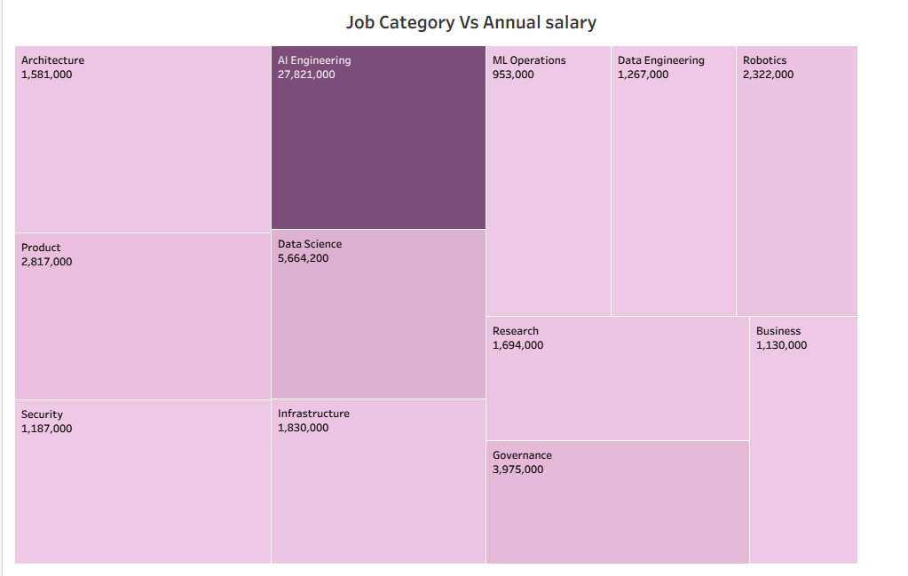

2. Job Title vs Annual Salary
Business Question:
Which AI job titles have the highest annual salaries?
Visualization:
Bar Chart – Job Title vs Annual Salary
Description:
This visualization compares the annual salary across different AI job titles. It helps identify which specific AI roles have higher salary values and allows comparison of compensation across job positions.
Report format:
2. Which AI job titles have the highest annual salaries?
Visualization: Bar chart showing annual salary by job title.
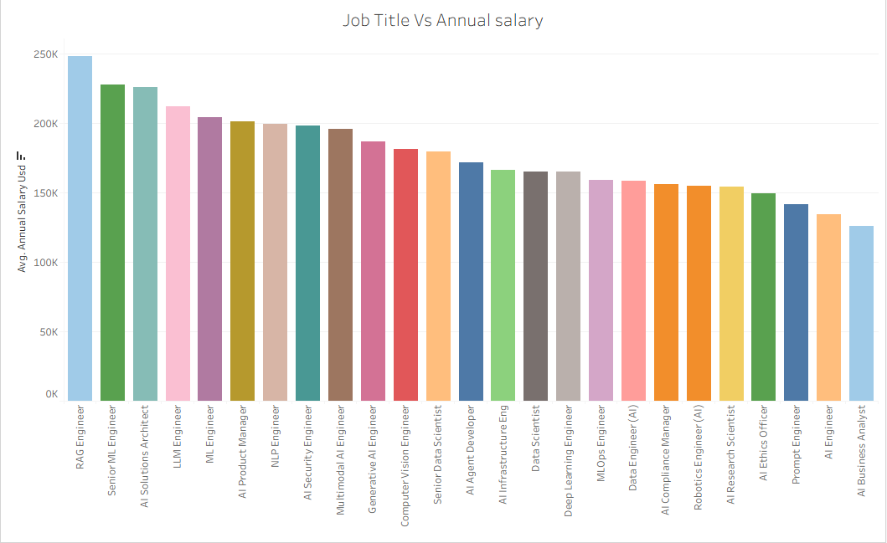

3. Company Size vs Salary
Business Question:
How does company size affect annual salary in the AI job market?
Visualization:
Bar Chart – Company Size vs Salary
Description:
This visualization compares salary values across different company-size categories. It helps analyze the relationship between company size and compensation in the AI job market.
Report format:
3. How does company size affect annual salary in the AI job market?
Visualization: Bar chart showing salary by company size.
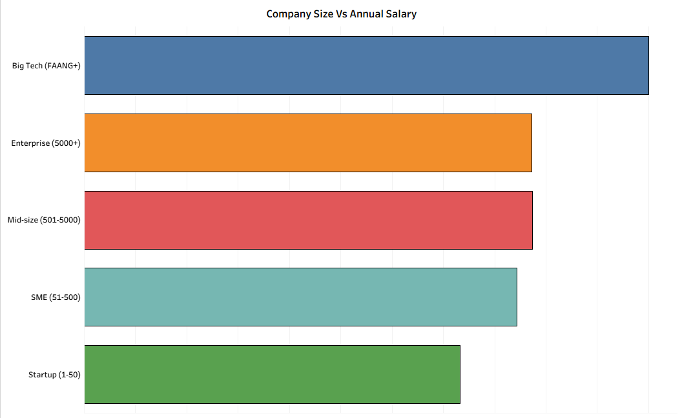

4. Key Performance Indicators (KPI)
Business Question:
What are the key performance indicators of the AI job market?
Visualization:
KPI Dashboard / KPI Cards
Description:
This visualization presents the main performance indicators of the AI job market in a concise format. It can be used to summarize important measures such as total jobs, salary, demand, and other relevant metrics available in the dataset.
Report format:
4. What are the key performance indicators of the AI job market?
Visualization: KPI cards/dashboard showing key AI job-market metrics.


5. Industry vs Salary
Business Question:
How does annual salary vary across different industries in the AI job market?
Visualization:
Bar Chart – Industry vs Salary
Description:
This visualization compares annual salary values across different industries. It helps identify salary differences between industries represented in the AI job-market dataset.
Report format:
6. How does annual salary vary across different industries in the AI job market?
Visualization: Bar chart showing salary by industry.

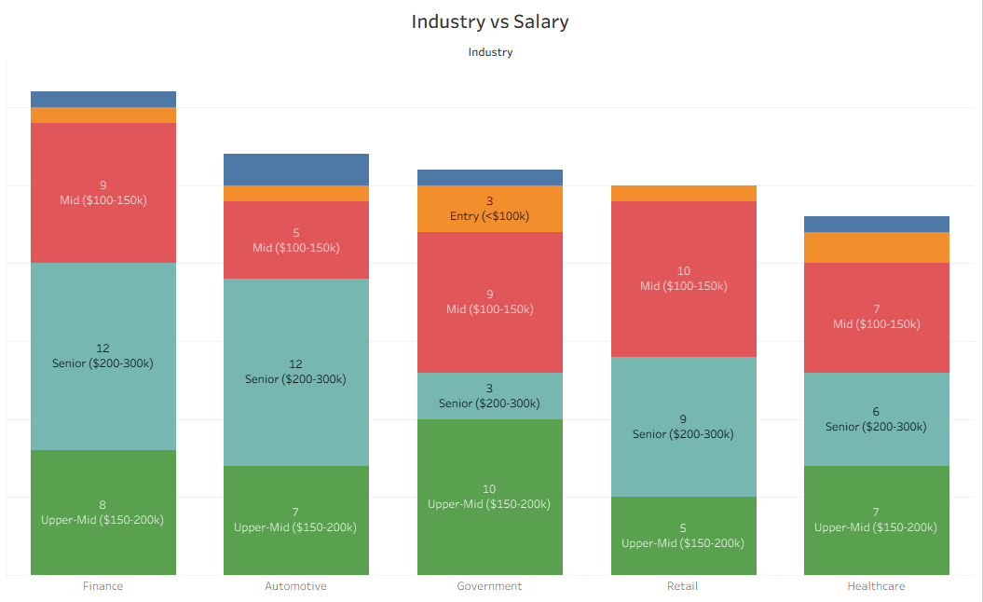

6. Number of Jobs Posted by Year
Business Question:
How has the number of AI jobs posted changed by year?
Visualization:
Bar Chart – Number of Jobs Posted by Year
Description:
This visualization shows the number of AI job postings for each year in the dataset. It helps compare job-posting volume across the available years.
Report format:
7. How has the number of AI jobs posted changed by year?
Visualization: Bar chart showing the number of jobs posted by year.
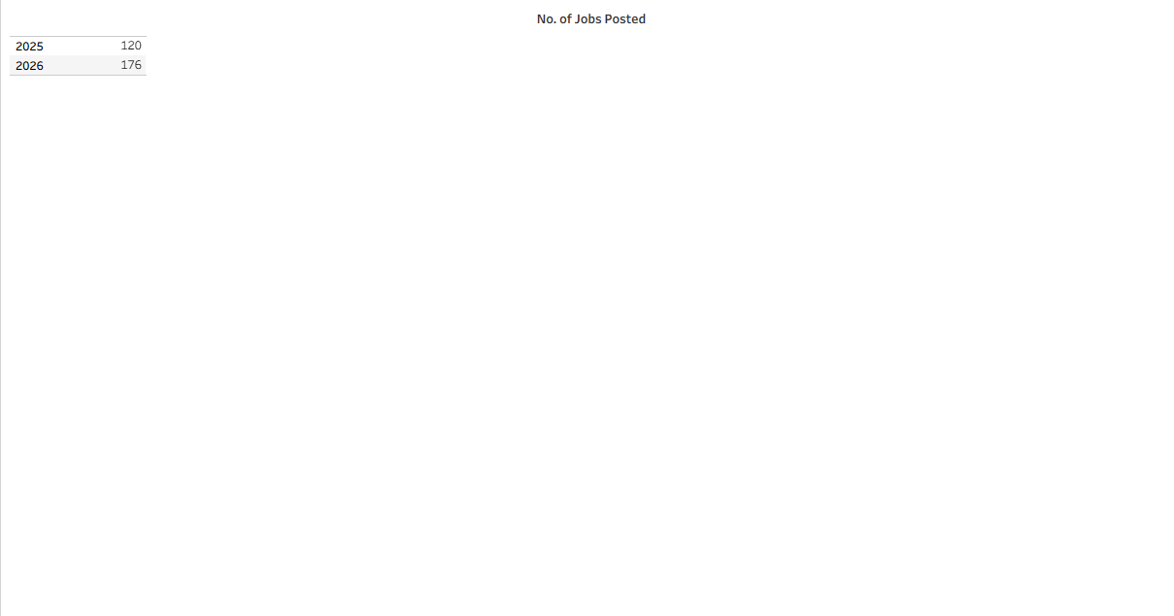

5. Job Title vs Job Count
Business Question:
Which AI job titles have the highest number of job postings?
Visualization:
Bar Chart – Job Title vs Job Count
Description:
This visualization compares the number of job postings for different AI job titles. It helps identify the job titles that appear most frequently in the dataset.
Report format:
5. Which AI job titles have the highest number of job postings?
Visualization: Bar chart showing job count by job title.

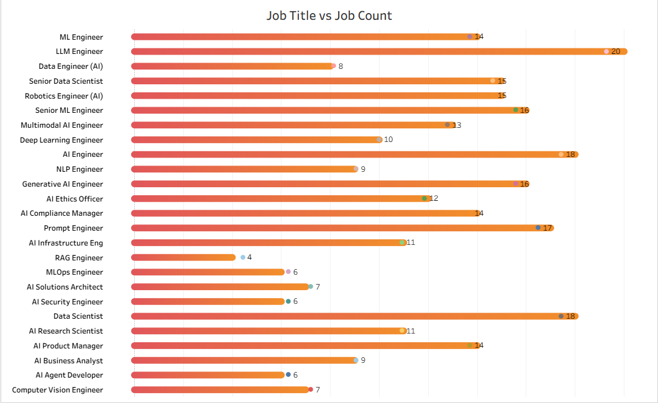

5. Dashboard
5.1. Dashboard Design File
Dashboard Design

Date | 05-September-2026
Team ID | -
Project Name | AI Career Pulse: Decoding the Job Market
Maximum Marks | 5 Marks

Creating an effective dashboard involves thoughtful design to ensure that the presented information is clear, relevant, and easily understandable for the intended audience. Here are some key principles and best practices for dashboard design
Activity 1: Interactive and visually appealing dashboards

Dashboard Design
Project Name: AI Career Pulse: Decoding the Job Market
Dashboard Title: AI Career Pulse – Decoding the Job Market
Dashboard Purpose:
To provide an interactive overview of the AI job market using salary, job count, job category, job title, company size, industry, and yearly job-posting data.
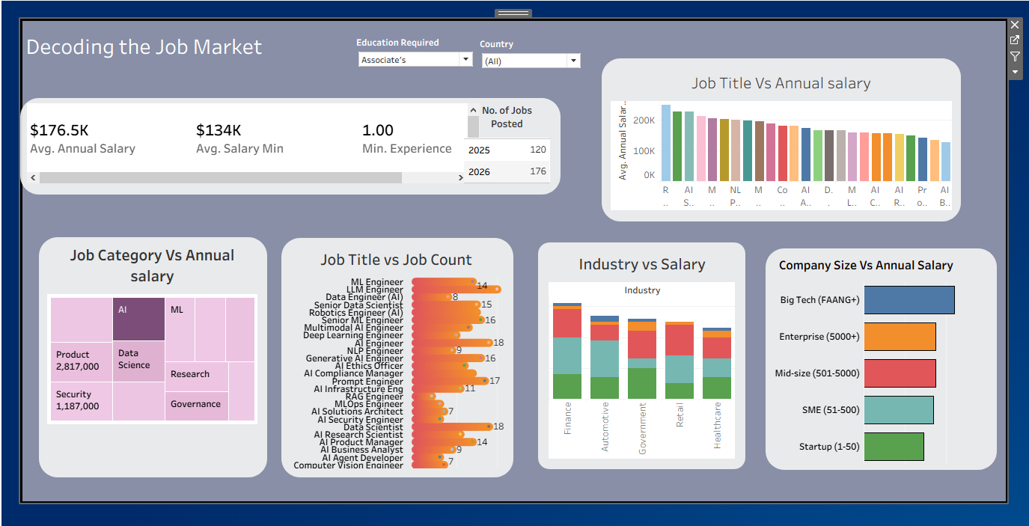

Dashboard Components
- KPI Cards
  - Total Number of Jobs
  - Average/Total Annual Salary
  - Number of Job Categories
  - Number of Industries
- Job Category vs Annual Salary
- Job Title vs Annual Salary
- Company Size vs Salary
- Job Title vs Job Count
- Industry vs Salary
- Number of Jobs Posted by Year

Interactive Features
- Job Category filter
- Job Title filter
- Industry filter
- Company Size filter
- Experience Level filter
- Country/Location filter
- Year filter

Activity 2
Publish Dashboard on Tableau Public and Paste the Dashboard Public link below:
Example
https://public.tableau.com/views/Book1_17878291336460/Dashboard1?:language=en-US&:sid=&:redirect=auth&:display_count=n&:origin=viz_share_link

6. Report
6.1. Story Design File
Story

Date | 05-September-2026
Team ID | -
Project Name | AI Career Pulse: Decoding the Job Market
Maximum Marks | 5 Marks

Story 1 – Actual Tableau Story
Your story currently contains 4 story points:
- Job Title vs Job Count
- Job Category vs Annual Salary
- Industry vs Annual Salary
- Company Size Vs Annual Salary

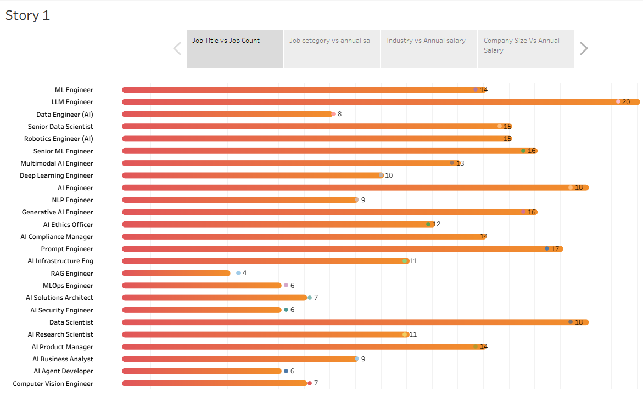

Story Design Report

Project Name: AI Career Pulse: Decoding the Job Market
Story Name: Story 1
Story Point | Visualization | Purpose / Observation
1. Job Title vs Job Count | Horizontal bar chart | Shows the number of job postings for different AI job titles and allows comparison of job-posting frequency.
2. Job Category vs Annual Salary | Treemap | Shows annual salary values across different AI job categories and provides a visual comparison of salary distribution.
3. Industry vs Annual Salary | Visualization comparing industry and annual salary | Shows how annual salary values vary across different industries in the AI job market.
4. Company Size Vs Annual Salary | Visualization comparing company size and annual salary | Shows the relationship between company size and annual salary values.

Activity 2:
Publish Story on Tableau Public and Paste Public link below
https://public.tableau.com/views/AIJobMarketAnalysisStory_17900095220170/Story1?:language=en-US&publish=yes&:sid=&:redirect=auth&:display_count=n&:origin=viz_share_link

7. Performance Testing
7.1 Utilization of Data filters
The Tableau dashboard uses interactive filters to allow users to explore the AI job market based on different dimensions. The filters can be applied to focus the analysis on specific job categories, job titles, industries, company sizes, experience levels, and other available fields.
Purpose:
Data filters improve dashboard usability by allowing users to view only the relevant portion of the dataset and perform focused analysis

7.2 No of Calculation Field
Calculated fields are used in Tableau where required to derive analytical measures from the available dataset. These calculations support salary analysis, job-count analysis, KPI development, and other dashboard visualizations.
Examples of calculated measures:
- Annual Salary measures
- Job Count
- Salary-related metrics
- KPI measures

7.3 No of Visualization
The project currently contains 7 visualization subtasks:
- Job Category vs Annual Salary
- Job Title vs Annual Salary
- Company Size vs Salary
- Key Performance Indicators (KPI)
- Job Title vs Job Count
- Industry vs Salary
- Number of Jobs Posted by Year
Total Number of Visualizations: 7

8. Conclusion/Observation
The AI Career Pulse: Decoding the Job Market project analyzes the AI job market using job titles, job categories, annual salary, company size, industry, and job-posting information.
The Tableau visualizations provide a consolidated view of salary patterns and job-posting distribution across different segments of the AI employment market. The Job Category vs Annual Salary, Job Title vs Annual Salary, Company Size vs Salary, and Industry vs Salary visualizations support salary-based analysis, while Job Title vs Job Count and Number of Jobs Posted by Year provide information about job availability and posting distribution.
The dashboard and Tableau Story bring these visualizations together into an interactive format, making the analysis easier to explore and understand.

9. Future Scope
The project can be extended in the future by:
- Adding more recent AI job-market data to maintain an up-to-date analysis.
- Including additional countries and geographical regions.
- Adding detailed skill-demand analysis to identify frequently requested AI skills.
- Comparing salaries across experience levels and education requirements.
- Adding remote-work and employment-type analysis.
- Developing predictive analysis for salary and job-demand trends.
- Connecting the Tableau dashboard to regularly updated data sources.
- Adding more interactive filters and drill-down features.
- Expanding the analysis to include emerging AI roles and technologies.

10. Appendix
10.1. Source Code(if any)
The project primarily uses Tableau Desktop/Public for data analysis and visualization.

10.2. GitHub & Project Demo Link

GitHub Repository: https://github.com/prashant321001001/Downloading-the-dataset

Project Demo: https://drive.google.com/file/d/11Vv2yvyD8Yk_0Lfgl7QFzXfH71BTbIB4/view?usp=drivesdk

